Rezoon Rasheed
Project Part 1

Babson Olin FW Graduate School of Business
Modern Econometrics for Business
Spring 2025

Professor Jessica Simon

Literature Review
The influence on housing price by various key amenities, which include proximity to train stations and schools, along with the floor area of the property and its distance from central business district are to be established by evidence in literature for further analysis. In the context of Perth, Australia, where suburban expansion has historically shaped the city’s landscape, understanding these factors would shed light of potential leads for buyers, policymakers, and investors alike.
- School Proximity Effecting Housing Prices
Multiple researchers emphasize that the presence of a school zone significantly boosts nearby housing prices. In Brisbane, Australia, Rajapaksa et al. (2020) find a 11% premium for homes within a high-ranking public-school catchment, reflecting parents’ willingness to invest in educational quality, but also a general increase in the premium of houses with schools closer to them. Mathur (2022) work a similarly pronounced “elite school” effect: average schools do not add much value, but proximity to these institutions drive prices up by a minimum of 13%. Taken together, these studies imply that only the schools truly command a premium on house prices, an insight that likely carries over to Perth, which has similar demographics to the cities of these research, and the mentality of the parents’ as remain constant.
- Transportation Infrastructure and Accessibility
A second critical factor in property valuations is proximity to public transport. Liu et al. (2024) use advanced modeling in Cardiff (UK) to reveal a non-linear relationship between house prices and distance from central business district, with house prices increasing between distance of 0 to 1.2 km, a decrease visible in 1.2 to 2.6 km, and a sparse deviation after it. Chen et al. (2019), analyzing Sydney’s Northwest Metro, show how values can temporarily drop during construction but rebound once a station opens. Their regression suggests that a 1% decrease in distance to a metro station yields a 0.037% price increase in houses. Xu et al. (2016) likewise demonstrates that commercial parcels in Wuhan, China, within 100 meters of a metro station gauged a 16.7% premium on house price. While the Perth rail system may not be identical to Wuhan’s, the general principle still holds, with property values tend to rise with convenient access to train lines.
- Impact of Floor Area
Apart from location, nearly all studies confirm that a bigger floor area typically had a positive influence on property prices. In this Dortmund case study, Wittowsky et al. (2020) establishes that each additional square meter of living space depicted a positive correlation within the variables. In contrast, simply adding more rooms without expanding total floor space did not improve the price per m²; in fact, having a greater number of rooms tended to lower the per-m² valuation. In context of Perth, where family homes often have multiple smaller rooms, this study implies that buyers tend to value the total square footage of a property more than simply having a larger number of rooms.
- Potential Interaction Terms: Distance to CBD, Amenities, and Space
Considering the literature, several authors highlight that core factors shortlisted can interact in meaningful ways. For instance, larger homes often fetch higher price premiums if they are also located near schools or near direct transit routes. On the other hand, suburbs farther out from the CBD might rely more on train station proximity to remain competitive, while those closer in might benefit primarily from walkability and ease of access to amenities.
Conclusion
Collectively, these studies converge on a few general concepts. First, distance to the CBD tends to generate a negative price gradient, but this pattern can flatten when outer suburbs offer better amenities, like train stations or schools. Second, rail infrastructure typically boosts property values in the longer run. Finally, bigger living spaces consistently imply a higher absolute price of houses, with subtle positive correlation with additional rooms.

Hypothesis and Regression

Research Question 1
What is the influence of Distance to the Central Business District on Price of Houses?
Hypothesis 1 (Null and Alternative):
- H₀: The distance to the central business district has no relation with price of house.
- H_{a}: The distance to the central business district has a negative relation with the price of house.
Research Question 2
What is the influence of floor area of a house on the price of the house?
Hypothesis 2 (Null and Alternative):
- H₀: The floor area of the house has no relation with price of house.
- H_{a}: The floor area has a positive relation with the price of house.

Summary of Variables
Price (Dependent Variable)
Price of houses is our focus as it shows how much people are willing to pay for a home. We excluded any properties with questionable or missing price data and took the natural log (lnPRICE) to handle the wide range of values as the distribution was left skewed. This helps us interpret differences in prices more clearly, since changes become odds rather than absolute amounts.
Distance to the Central Business District (CBD_DIST)
This variable captures how far a property is from Perth’s Central Business District. Homes nearer to the CBD generally sell for more, thanks to easier access to jobs and entertainment. We used lnCBD_DIST to counter the irregular distribution of data for the original variable.
Floor Area (FLOOR_AREA)
With the hypothesis of increase floor area leading to added premium in house price, this variable was considered. We removed any NA values which existed in the data. The log of floor area, lnFLOOR_AREA was taken as the original data distribution was left skewed.
Distance to the Nearest School (NEAREST_SCH_DIST)
According to literature, parents tend to be mindful of school proximity when it come to purchase of a house. The variable was log transformed (lnNEAREST_SCH_DIST) due to left skewness in the data distribution of the original variable, and rows that lacked valid information were removed.
Distance to the Nearest Train Station (NEAREST_STN_DIST)
Accessibility to public transport seemed to be an influencing factor in increasing property’s appeal. This variable was also transformed by natural log (lnNEAREST_STN_DIST) due to left skewed distribution.
Interaction Term (CBD_DIST_x_FLOOR_AREA)
In order to examine whether the impact of distance on price changes with property size, we first multiplied CBD_DIST by FLOOR_AREA and then applied a log transformation to each factor. This allows us to investigate if larger houses are affected differently based on their distance from the city center.
Data Cleaning
We limited our dataset to properties sold in 2020 and standardized the date format to ensure everything lined up properly. Whenever a key piece of information was missing in the dataset, we omitted that record. The goal was a clean, consistent dataset that accurately reflects how these features (predictors) shape housing prices.

Appendix
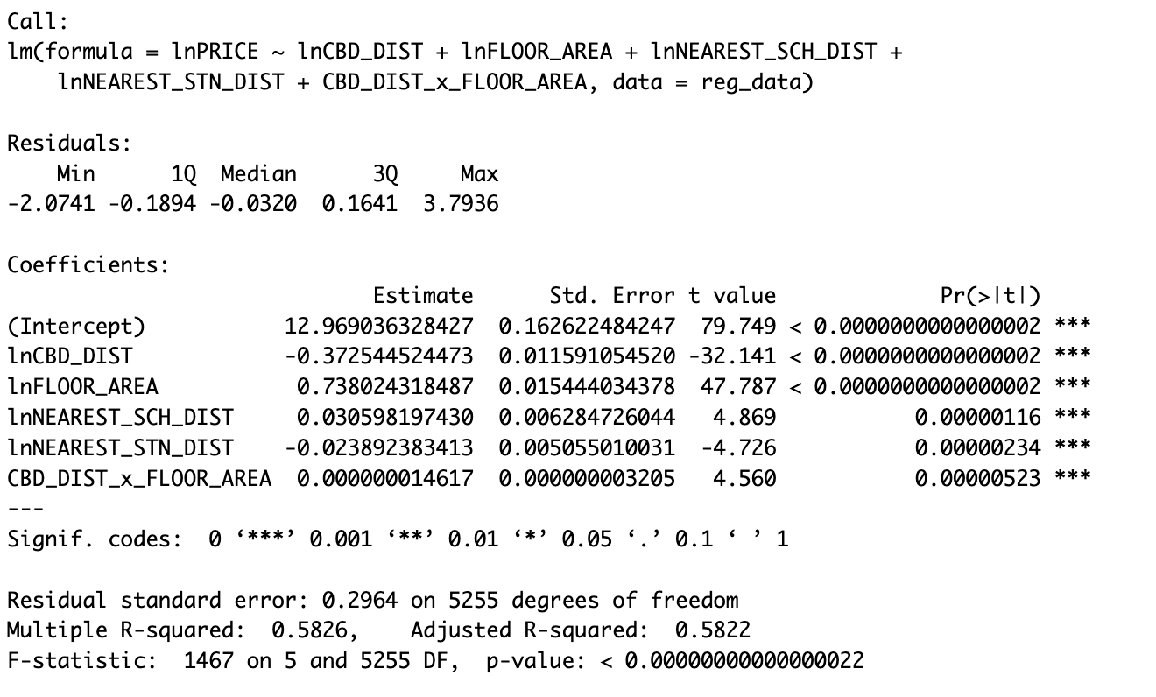

Bibliography

Dirk, W., Josje, H., Janina, W., & Michael, S. (2020). Residential housing prices: impact of housing characteriﬆics, accessibility and neighbouring apartments – a case ﬆudy of Dortmund, Germany. Urban, Planning and Transport Research.
Gono, M., Rajapaksa, D., Clevo, W., Shunsuke, M., Boon, L., & Viet-Ngu, H. (2020). The demand for education: The impacts of good schools on property values in Brisbane, Australia. Land Use Policy.
Shishir, M. (2022). Non-linear and weakly monotonic relationship between school quality and house prices. Land Use Policy.
Tao, X., Ming, Z., & Paulus, T. A. (2016). The impact of urban rail transit on commercial property value: New Evidence from Wuhan, China. Transportation Research Part A Policy and Practice .
Xiang, L., Xiaohong, C., Scott, O., Mingshu, T., & Guojian, Z. (2024). Does better accessibility always mean higher house prices? Urban Analytics and City Science.
Yuer, C., Maziar, Y., Mohammad, M., & Sidney, N. (2019). The impact on neighbourhood residential property valuations of a newly proposed public transport project: The Sydney Northwest Metro case study. Transportation Research Interdisciplinary Perspectives.

